

***Queen Elizabeth II High School***

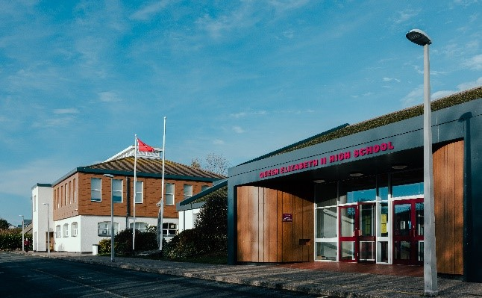

What a brilliant start to the new academic year. It has been wonderful to welcome new students and their families to the school community. Our Year 7 students have settled in very well and our new students in other

year groups have also had a very positive start to the year.

We would like to take this opportunity to introduce several new members of staff –

Ms Drane is the new Head of Modern Foreign Languages (MFL) and teacher of French. Ms Boxleitner also joins the MFL Department as teacher of German. Mr Callow joins the Maths Department and Mrs Dunn joins the

PE Department. Mr Dunn, Mrs Kelly and Ms Lightfoot all join the Science Department and Mr O’Loan joins Performing Arts. Mr Horbury joins us as Cover Supervisor and Ms Mattio joins the team in Support for Learning.

We also welcome Mrs Ozer, who joined us towards the end of the Summer Term as our new School Business Manager. Miss Bradbury joined the Religious Studies (RS) Department during the Summer Term and Mrs Parr has also now joined the RS Department. We have recently welcomed Mr Kennedy as the new Assistant Site Manager.

We welcome all new members of the school community and hope that their time here will be happy and successful.

**Special points of interest…..**

**● Welcome**

**● Our School Vision**

**● Communications**

**● Lunch Passes**

**● 2024 Exams**

**● Anti-Bullying**

**● English Department**

**News**

**● PE Department News**

**● Celebrating Success**

**● QEII High School**

**Association News**

**● Important dates**

**and much more!**

**Autumn 2023 Newsletter**

***Douglas Road, Peel, Isle of Man IM5 1RD***

***Telephone – 01624 841000***

***Student-related email – 7054003@sims-communications.co.uk***

***General email – qe2enquiries@sch.im***

***School website – https://qe2.sch.im/***

***Facebook – www.facebook.com/QE2IOM***

***Headteacher – Mrs C Clarke***

**Welcome!**

**Our School Vision - *‘Always strive to do your utmost’***

* We will strive for excellence, be a forward thinking, inclusive and nurturing school which enables our students to achieve well, enriching their lives.
* We believe that high quality teaching, learning and leadership are fundamental to our success. We will create a culture of learning, collaboration, evidence informed practice and innovation.
* We will embed ambition in our students to enable them to lead a balanced life as adults, capable of contributing to society.

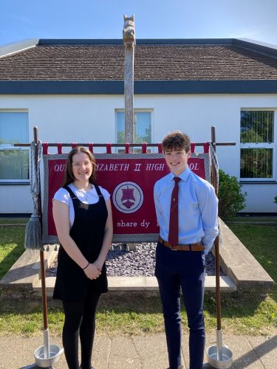

**Data Collection Forms**

Thank you to everyone who has already completed and returned the Data Collection Forms. If you haven’t already done so, we would be grateful if you could return them as soon as possible.

We would also be grateful if you could remember to let us know if you change your address or contact details during the year, as it is vital that we have up to date information at all times.

**Please remember to include your child’s full name in any communications with the school so that they can be easily identified by the Admin Team. Thank you.**

**Communications**

For those of you who are new to the school, our newsletters will be published each term, however, you can receive regular updates via our school Facebook page and website. Please ensure that you visit these sites as they may have important information which is relevant to your child.

***School website –*** [***https://qe2.sch.im/***](https://qe2.sch.im/)

***Facebook – www.facebook.com/QE2IOM***

You can also scan our QR code with your mobile device to take you directly to our website –

Please send student-related emails to either [***7054003@sims-communications.co.uk***](mailto:7054003@sims-communications.co.uk)or to our general email address

[***qe2enquiries@sch.im***](mailto:qe2enquiries@sch.im)



**Lunch Passes**

If you have not completed an application form since we returned to school at the beginning of September, and would like to give permission for your child to leave school during lunchtime, please ask your child to collect an application form from Reception. We require the application form to be completed each academic year - lunch passes do not automatically get renewed from one year to the next.

If any children leave school during lunchtime without permission, it will be viewed as a serious safeguarding concern and will warrant further consequences.

**Introducing our Head Students for this year, Kitty Ayres and Josh Bull -**

**GCSE/iGCSE, AS and A Level Exams - Summer 2024**

**Contingency exam days for Summer 2024.**

In the event of national or significant local disruption to exams, the contingency days for Summer 2024 are as follows:

Thursday 6th June 2024

Thursday 13th June 2024

The standard contingency day remains at the end of the timetable, being scheduled on Wednesday 26th June.

**Candidates are encouraged to remain available until Wednesday 26th June 2024 should examinations need to be rescheduled.**

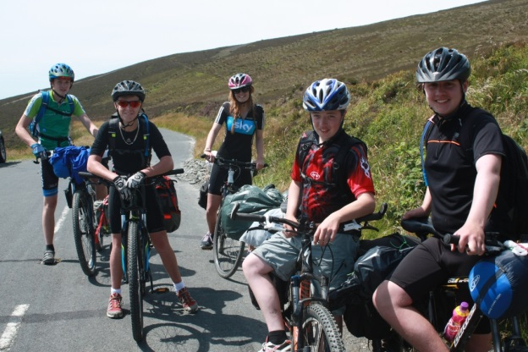

**If your child is ill**

If your child is ill, please keep them at home until they are feeling better.

If necessary, seek medical advice and do not send your child back to school until symptoms have passed and/or any exclusion times have elapsed.

**Please also remember to advise the school as early as possible of any absences by telephone or email.**

**Anti-Bullying**

Queen Elizabeth II High School is committed to creating and sustaining a safe, positive and inclusive environment for all students, staff and parents/carers.

More information about our Anti-Bullying Policy can be found on our school website –

<https://qe2.sch.im/pages/index/view/id/100/Anti-Bullying>

Our online Bullying Report Form can also be found on this page or by scanning the QR Code below with your mobile device –



QEII are proud of our diverse community, so recently we were pleased to once again be celebrating European Day of Languages.

All students should have heard and seen other languages and cultures in and around their lessons and enjoyed form time quizzes, videos, and something a little different in their lessons, to highlight the importance of learning, appreciating and respecting other languages, cultures and traditions.

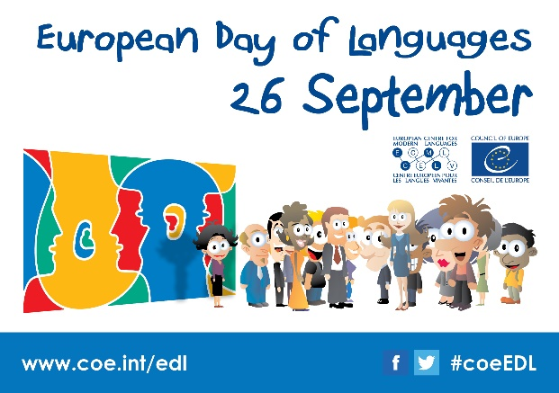

**An appeal from our**

**Library…….**

If you are looking to re-home books that are in a good condition, please think of our school Library – we are

always willing to take donations!

**Thank you.**

**LITERACY FOCUS**

Introducing **‘Bedrock’** – our new vocabulary builder for Years 7 and 8.

Year 7 and 8 students will shortly be given log-ins to the Bedrock app. Bedrock ensures that students continue to learn ambitious vocabulary through fiction and non-fiction texts. It also supports reading progress and literacy. Students will be able to access the app via their phones, tablets or a computer.

Parents will also receive a log in so that they can monitor their child’s progress. To ensure that all students gain the maximum benefit from this, they will be set 25 minutes per week as part of their English homework. Students who do not have access to a computer at home can complete it in the Library at lunchtime or at Homework Club.

Ms Edwards will be sending a video home to all KS3 students to explain what the initiative is and how you can support your child.

**English Department News**

**…………………………………………………**

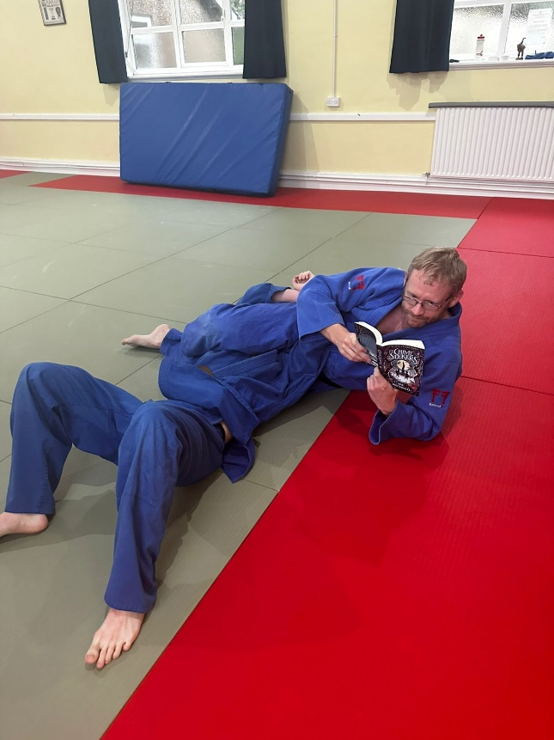

**SUMMER BOOK CLUB – YEAR 7**

You may have seen very strange photos on Facebook of teachers reading ‘The Chime Seekers’ book in rather strange places!

As part of our new Reading for Pleasure Strategy, all new Year 7s were given a copy of the book and some activities they could complete over the holiday. On their arrival at QEII, we have talked about their thoughts on it and watched a Q and A with the writer, Ross Montgomery, who talked about his inspiration for the story and tips for budding writers.

Ross also chose a winner from the teacher pictures and chose Mr Horton’s picture as the best. Congratulations to Mr Horton! A big thank you to QEII High School Association for purchasing the books for us. We hope to continue the initiative next year.

(Copies of the book are available in the Library should any other students wish to read it).



**RECOMMENDED BOOKS FOR YEAR 7 AND YEAR 8**

The QEII Debate Club is now up and running on Thursday lunchtimes. Debate Club is open to all year groups, and depending on interest we may then split into Years 7 - 9 and Years 10 - 13.

Students will get the chance to experience:

* choosing topics (‘motions’) for debate
* developing their own arguments
* debating with each other, in informal and competitive debate formats

There is the potential for competitions within school, joining the Manx Debating League with other secondary schools, and entering other public speaking and debating competitions on the Island or further afield.

No experience is necessary – if you are someone who cares, who has an opinion, who wants to develop your confidence in speaking in front of others, arguing or negotiating, or who has an interest in research, this could be the club for you.

Come along on Thursday lunchtimes to find out more - 12.45pm - 1.10pm in D22 (in the English Department).

**The Wolves of Willoughby Place by Joan Aiken**

A classic, set in an alternative reality in a ‘time that never happened’. There are wolves outside the walls of Willoughby Place, but for cousins, Bonnie and Sylvia, the real danger lies inside. Their wicked governess, Miss Slighcarp, is working with a network of criminals, forgers and snitches to carry out a terrible plan.

Set in an alternative 1832, in which Good King James III is on the throne, and Britain is ravaged by wolves which have migrated through the newly-opened Channel Tunnel, this book is brilliantly inventive and imaginative!

**Hacking, Heists & Flaming Arrows by Robert Muchamore**

An ideal book for those who enjoy an adrenaline-filled read! A modern day telling of the merry band of brothers who rob from the rich to give to the poor!

The characters and setting is brought bang up to date with the Sheriff of Nottingham – obsessed with power and money, in cahoots with Guy Gisborne – the underworld and organised crime boss. After his dad is framed for a robbery, Robin teams up with Little John and Marion, and using their inimitable tech skills, plan their revenge on the baddies……



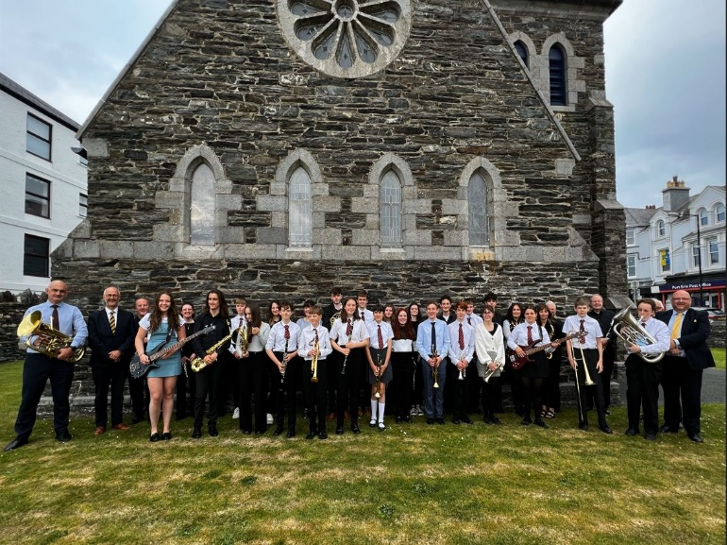

The band would like to thank everyone who came along to listen and support them on the evening. They would also especially like to thank QEII High School Association for funding the hire costs of the coach and the evening meal.

Band practices have now restarted on a Friday evening between 3.15pm and 4.15pm and new members who play a brass, woodwind or percussion instrument at approximately Grade 1 standard or above are very welcome. Please contact Mr Kinley

for more information.

**Wind Band perform in Port Erin**

At the end of last term, the school wind band, conducted by Mr Kinley, performed in St Catherine’s Church in Port Erin as part of the prestigious Rushen Parish series of concerts. The band travelled down to the south of the Island during the afternoon by coach, so they could rehearse in the church before enjoying an evening meal in the Station Hotel.

A near capacity audience were then treated to an hour-long concert which included music made famous by Queen, Neil Diamond and Taylor Swift and film themes from ‘Forrest Gump’, ‘Encanto’ and ‘How To Train Your Dragon’. It was also the perfect way to provide a last concert for eight of last year’s Year 13 students, the majority of whom have been in the band since they were in Year 7!

On Friday 20th October, our QEII community will have a unique opportunity to wear the colour red as part of a powerful initiative aimed at promoting awareness of anti-racism. The event is in collaboration with ‘Show Racism the Red Card’, an organisation dedicated to combating racism.

Leading the event is Mrs Lewis, along with a group of passionate students who have been working together to deliver impactful assemblies, raising awareness about the importance of anti-racsim and advocating for a more inclusive and equitable society. By wearing red on this significant day, the school community unites in a visual statement against racism and a commitment to fostering a more just and inclusive society for all.

**The PE Department CARE**

The PE Department is a very busy place at the moment!

With clubs on before school, every lunchtime and after school, for all year groups, there are over 300 students attending each week, which is fantastic and we hope the numbers will continue to grow.

There are a variety of clubs on offer every lunchtime where we aim to cater for all – the fitness suite, table tennis, badminton, dodgeball, boxing, basketball and a PE support session.

After school we have practices for all year groups for the hockey and rugby teams, a running group, cycling, body pump, girls’ rugby and handball.

There are so many opportunities and we encourage everyone to have the **COURAGE** to come along and get involved!

School fixtures have now started and students have been working hard to prepare for these fixtures. Anyone can attend practices – it is not too late, so **ASPIRE** to represent our school!

Team sheets will always be posted on the noticeboards, so be sure to look at them to see who we are playing and when.

Year 7 are currently taking part in an Inter-Form bench ball competition every Thursday morning. This is all about building relationships, getting to know each other, practicing those lifelong skills of communication, self-awareness and **RESPECT**. It is a brilliant way to start the day and everyone is enjoying it - the tutors are getting involved as much as the students!

Links with the community are continuing to grow and the PE Department **ENDEAVOUR** to show our students what is out there in the community to hopefully encourage lifelong participation. Unfortunately, the Western 6 event had to be postponed, however, we hope to rearrange this soon, giving local sports clubs the opportunity to come in to school, deliver sports sessions to the whole of Year 7 with the intended outcome of showing students a pathway outside of school. It is a brilliant event and something for the students to look forward to.

In our KS4 Games lessons, the PE Department have looked into the community to broaden the opportunities for our older students. Students now have more flexibility on what their Games lesson will look like and some students are enjoying climbing sessions at Hot Rocks, outdoor adventurous activities with the Venture Centre, trail walking and fitness classes at West Coast Fitness. There are plans in the future for swimming and golf sessions to name a couple. We are hoping to make sport and fitness accessible to all.

Our BTEC Sport students and Sports Leaders have been enjoying the new Kelvin Dawson Suite at the Tommy Clucas Hall for their lessons. The facility is such a professional setting for their learning, with high-tech equipment and a practical space downstairs. We are all very lucky to have the use of this facility.

We have so many talented students in our school and would love to hear all about their achievements – please let us know so we can celebrate their success with you!

**The PE Department has its own Facebook page celebrating sporting successes and giving other useful information. Be sure to follow us -**

<https://www.facebook.com/Queen-Elizabeth-II-High-School-Sport-139995876459199/?fref=pb&hc_location=profile_browser>

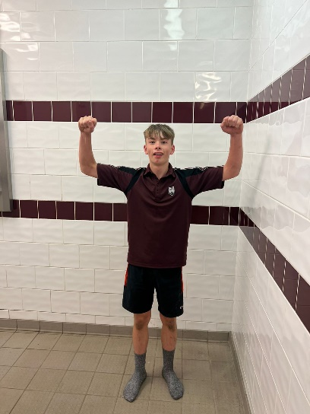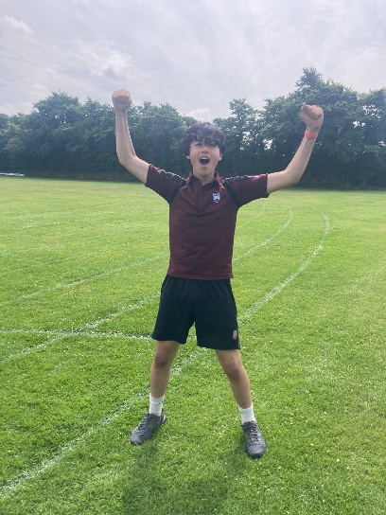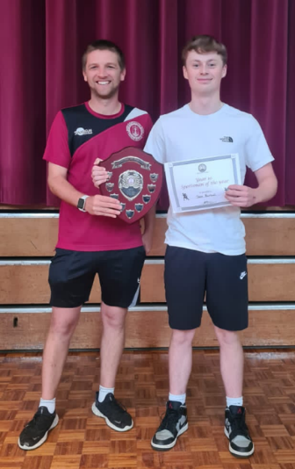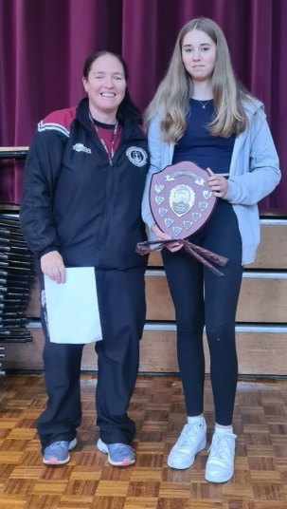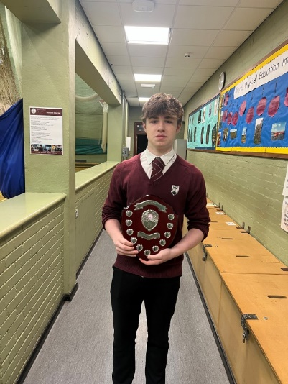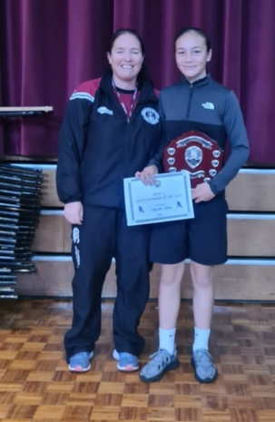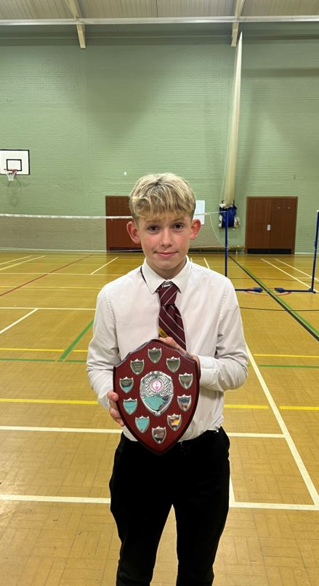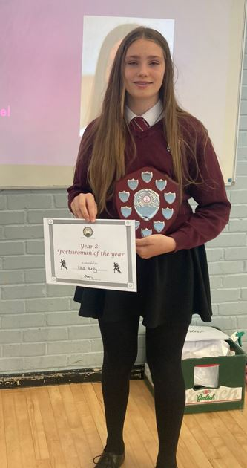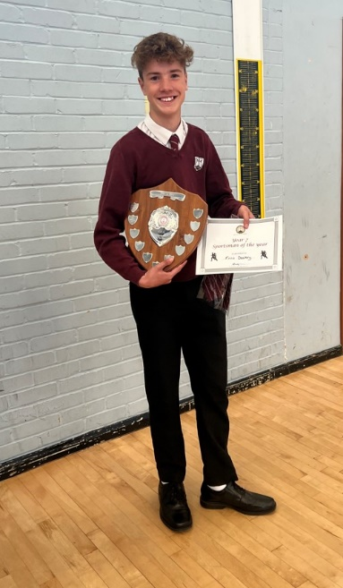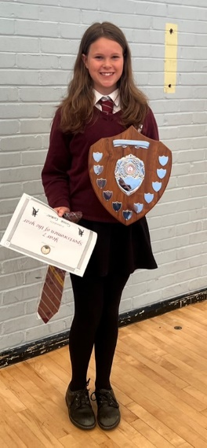

**Record breakers!**

Congratulations to Daniel (now Year 8) pictured left, who in the Summer Term broke the school record for the Year 7 boys 200m with a time of 28.15 seconds.

Another Daniel (also now Year 8) and pictured right, was the other record breaker on Sports Day, taking the Year 7 boys 800m record with a time of 2.31, narrowly edging out P Quirk from 1991.

Here are just a few of our talented students who received recognition with Sports Awards during the Summer Term.

Sam – Year 10

Sportsman of the Year

Poppy – Year 10

Sportswoman of the Year

William – Year 9

Sportsman of the Year

May-Saa – Year 9

Sportswoman of the Year

Teddy – Year 8

Sportsman of the Year

Isla – Year 8

Sportswoman of the Year

Finlo – Year 7

Sportsman of the Year

Grace – Year 7

Sportswoman of the Year

**2023 Sports Awards**

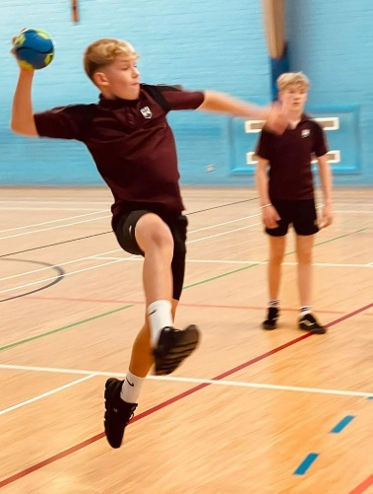

We have a number of students who have excelled in sport and have been awarded their school colours.

Our school colours ties are awarded to students who show great commitment and attitude consistently when representing the school. They demonstrate excellence in multiple sports and are students who their peers can aspire to emulate. These are awarded at Junior (Y7 & 8), Intermediate (Y9 & 10) and Senior level. The students can wear their ties in school with pride.

**Year 7 (now Year 8)**

Aaron Chhetri, Grace Cottier, Finlo Dealtry, Lexi Gates, Thomas Hutchinson, Fergus Kerwick, Kaylee Lewney, Oliver McKeown, Bronte Morrison, Tibby O’Toole

……………………………………….

**Year 8 (now Year 9)**

New – Isla Kelly, Laila Paradise

Already held – Scarlett Callister, Beth Christian, Aimee Doran, Archie Hatton, Niall Howland, Lettie Hyett,

James Kemp, Sam Morris, Ella Quirk, John Roberts, Teddy Thompson

……………………………………….

**Year 9 (now Year 10)**

Izzie Burns, Ewan Higgins, Francesca Loader, Neve Madden, May-Saa Smith, Seb Smith, William Taylor

……………………………………….

**Year 10 (now Year 11)**

New – Henry Barwood, Poppy Bregazzi, Charlie Cain, Abbie Griffin, Toby Hemuss, Ciaran Kelly, Harry Perks, Alex Stewart

Already held – Dominic Andrea, Olivia Bettridge, Oscar Bignall, Sam Burrows, Fern Corlett,

Andrea Ecolango, Connie Graham, Oliver Howard, Aalin Mayers, Shannon Saunders, George Taylor,

Ben Woodbridge

**Congratulations to you all!**

**Handball**

QEII played their inaugural handball fixture against Ramsey Grammar School during the Summer Term.

Despite not having played all that much the boys involved progressed quickly through the game and their enthusiasm is now growing.

The Western Warriors Handball Club train on a Monday after school led by Mr Parr and Mr Sinclair.

**School Colours**

**Celebrating Success**

As mentioned previously, we are always delighted to hear about current and former students’ successes and below are just a few recent triumphs outside school!

………………………………………………………………………………..

………………………………………………………………………………..

Congratulations to Lauren (Year 10) who was recently crowned age 14 years English national champion at the British and English Summer Swimming Championships.

On the back of this achievement, she has been selected for the National Age Group Development Programme which provides a pathway to support young swimmers in their quest to achieve senior international podium success.

Good luck Lauren – we are all really proud of you!

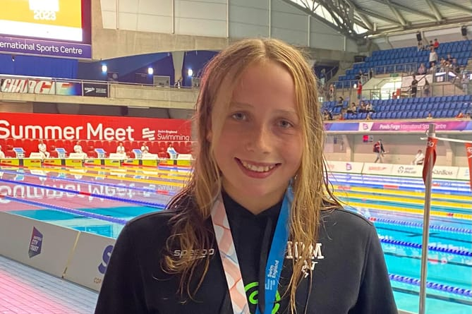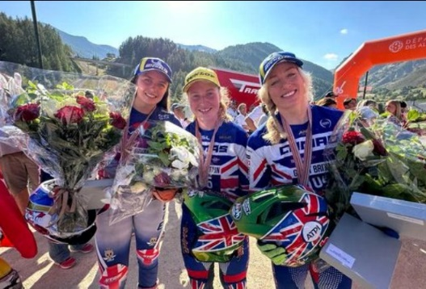

Kaytlyn Adshead, who left QEII this summer after

completing her A Levels, won Gold Medal on

Sunday 10th September as part of the Great Britain team who won the ‘Trials des Nations’ in France.

Kaytlyn, along with Alice Minta and 9-time World Champion, Emma Bristow, finished in first place in the Motorcycle Trials World Championship event, topping the rostrum ahead of Spain and Norway.

Kaytlyn's contribution was recognised by team-mate Emma, and the girls received a standing ovation on the podium.

Very well done to TJ (Year 11) who is currently leading the Junior Bangers Stockcars Championships - a combination championship with England and the Isle of Man.

Kaytlyn also gained a Bronze in the Women’s Trials European Championships over the summer.

We wish Kaytlyn every success going forward!

**QEII High School Association**

**News and Events**

A very big **THANK YOU** to all our loyal supporters!

QEII High School Association is a registered charity and is run by enthusiastic volunteers who arrange fundraising events throughout the year. Our next meeting will be our AGM taking place on **Thursday 18th January 2024 at 5.30pm** in the school Library. This will then be followed by the Ordinary Meeting.



<https://www.facebook.com/QEIIPeel>

**Dates for your diary……**

**Wednesday 29th November -** our **Christmas Fayre** will be heldin the Main Hall between 6.00pm and 8.30pm.

Stalls are £15.00 each. If you would like to reserve a stall, please call Sue Ferns in the school Office on 841000.

On the night there will be a great selection of stalls from local crafters and traders, a Winter Grotto, student stalls and

games, refreshments and some fabulous raffle prizes up for grabs!

Admission is £1.00 for adults, which includes entry into a Lucky Programme Draw, 50 pence for children and free for

under 5’s.

**Thursday 18th January 2024 -** our **AGM** will be held at 5.30pm in the School Library. This will be followed by the

Ordinary Meeting.

**Raffle Prizes**

We will generally hold a Raffle at each of our fundraising events and are always grateful to receive donations of prizes. If you have any suitable items that you would be willing to donate, please drop them off at the school Reception.

**Many thanks.**

**(Isle of Man Registered Charity Number 799)**



**Friday 13th October -** an evening with **‘Retrospect’** from 8pm. This is always a fabulous evening and there are now just a few tickets remaining. If you would like to come along, please contact the school Reception on 841000 as soon as possible to check availability. Tickets are just £20.00 each.

QEII High School Association has its own Facebook page. For useful information please be sure to follow us –

**April**

**Tuesday 2nd – Tuesday 9th April –** Barcelona Trip

**January**

**Thursday 18th January –** QEII High School Association AGM, 5.30pm in the school Library

**Tuesday 23rd January –**

Year 7 Parents’ Evening

**October**

**Friday 13th October –** QEII High School Association host an evening with ‘Retrospect’, 8.00pm

**Tuesday 17th October –** Year 9

Parents’ Evening

**Monday 23rd – Friday 27th October –** Half Term

**Important dates…….**

**July**

**Monday 1st – Thursday 4th July –** Year 12 Mock Exams

**Friday 5th July –** Tynwald Day

**Monday 8th – Friday 12th July –** University Trip

**Friday 19th July –** School closes for Summer Term

**June**

**Monday 3rd – Friday 7th June –** Half Term

**Wednesday 12th June –** ReserveHeats Day

**Monday 17th – Tuesday 18th June –** New Intake Days

**Tuesday 25th June –** Sports Day

**Wednesday 26th June –** ReserveSports Day

**May**

**Monday 6th May –** Bank Holiday

**Tuesday 21st May –** Heats Day

**Monday 27th May –** Bank Holiday

**Tuesday 28th – Thursday 30th May –** Year 9 Exams

**Friday 31st May –** Inset Day (School closed to students)

**November**

**Thursday 9th November –**

Flu Immunisations for Years 7 to 11

**Monday 13th – Tuesday 21st November –** Year 11 Mock Exams

**Wednesday 22nd November –** Roadshow andOpen Evening for Year 6 children and parents

**Monday 27th November – Friday 1st December –** Year 13 Mock Exams

**Wednesday 29th November –**

QEII High School Association Christmas Fayre, 6.00pm until 8.30pm in the Main Hall

**March**

**Monday 4th– Friday 8th March –** Year 10 Mock Exams

**Wednesday 13th March –**

14 - 19 Information Evening for Year 9 and Year 11

**Thursday 21st March –**

Year 10 Parents’ Evening

**Wednesday 27th March –**

Spring Showcase

**Friday 29th March – Friday 12th April (inclusive) –** Easter Holidays

**February**

**Friday 2nd February –**

Wind Band Concert (TBC)

**Wednesday 7th February –**

Year 8 Parents’ Evening

**Wednesday 14th February –**

Year 8 HPV Vaccinations

**Thursday 15th February –**

Dance Showcase

**Friday 16th – Tuesday 20th February –** Belgium Trip

**Monday 19th – Friday 23rd February –** Half Term

**December**

**Thursday 7th December –**

Year 11 Parents’ Evening

**Thursday 14th December –**

Years 12 and 13 Parents’ Evening

**Thursday 14th – Friday 15th December –** Drama Show

‘A Christmas Carol’

**Wednesday 20th December –**

Annual Prize Giving

**Monday 25th December – Friday 5th January 2023 –** Christmas Holidays

**Summer 2014 Results Days**

**GCE – Thursday, 14th August**

**GCSE – Thursday 21st August**

Results are available from **9.30am** onwards in the Sixth Form Block.

You can only collect your own results. If you are unable to collect your results in person, you may authorise someone else to collect them on your behalf. This authorisation **MUST** be in writing. Alternatively, if you provide a stamped addressed envelope before you leave School, we will post your results to you.

Results **WILL NOT** be supplied by telephone, fax or email under **ANY** circumstances.

**No results will be given out to anyone else without a letter of permission.**