

***Queen Elizabeth II High School***

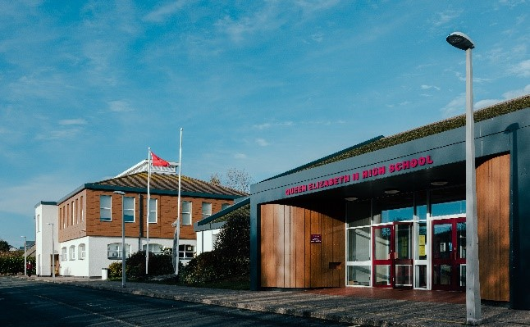

What a brilliant start to the new academic year. It has been wonderful to welcome new students and their families to the school community. Our

Year 7 students have settled in very well and our new students in other

year groups have also had a very positive start to the year.

We would also like to take this opportunity to introduce several new members of staff –

Ms Benziane is our new Head of English and Mr Gleig and Miss Moran also join the English Department. Mr Jelly joins us as the new Deputy Director of Key Stage 3 and Mrs Lund and Mrs Miller both join us as Directors of Personal Development. Mrs Brown joins the Science Department, Mr Moore joins the Religious Education Department, Mr Moffatt joins us as a Teacher of PE and Games and we welcome Miss Keggin as a Trainee Maths Teacher.

We also welcome Miss Kearney to the Support for Learning Team,

Mrs Corlett joins the Specialist Provision Centre and Mrs Prizevs joins the Site Staff Team.

We welcome all new members of the school community and hope that their time here will be happy and successful.

***Douglas Road, Peel, Isle of Man IM5 1RD***

***Telephone – 01624 841000***

***Student-related email – 7054003@sims-communications.co.uk***

***General email – qe2enquiries@sch.im***

***School website – https://qe2.sch.im/***

***Facebook – www.facebook.com/QE2IOM***

***Headteacher – Mrs C Clarke***

**Welcome!**

**Special points of interest…..**

**● Welcome**

**● Our School Vision**

**● Communications**

**● Lunch Passes**

**● Anti-Bullying**

**● Enrichment Clubs**

**● Annual Prize Giving**

**● QEII High School**

**Association News**

**● Important dates**

**and much more!**

**Autumn 2024 Newsletter**

**Our School Vision - *‘Always strive to do your utmost’***

* We will strive for excellence, be a forward thinking, inclusive and nurturing school which enables our students to achieve well, enriching their lives.
* We believe that high quality teaching, learning and leadership are fundamental to our success. We will create a culture of learning, collaboration, evidence informed practice and innovation.
* We will embed ambition in our students to enable them to lead a balanced life as adults, capable of contributing to society.

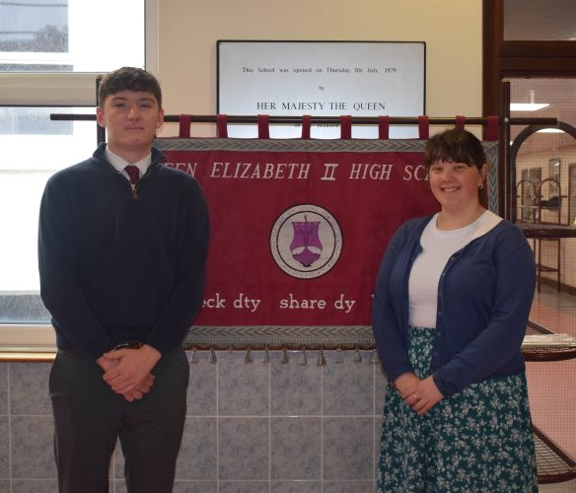

**Data Collection Forms**

Thank you to everyone who has already completed and returned their Data Collection Form. If you haven’t already done so, we would be grateful if you could return them

**as soon as possible.**

We would also be grateful if you could remember to let us know if you change your address or contact details during the year, as it is vital that we have up to date information at all times.

**Please remember to include your child’s full name in any communications with the school so that they can be easily identified by the Admin Team. Thank you.**

**Introducing our Head Students for this academic year, Ealish Ayres and Aidan Kelly**

**Communications**

For those of you who are new to the school, our newsletters will be published each term, however, you can receive regular updates via our school Facebook page and website. Please ensure that you visit these sites as they may have important information which is relevant to your child.

***School website –*** [***https://qe2.sch.im/***](https://qe2.sch.im/)

***Facebook –*** [***www.facebook.com/QE2IOM***](http://www.facebook.com/QE2IOM)

You can also scan our QR code with your mobile device to take you directly to our website –

Please send student-related emails to either [***7054003@sims-communications.co.uk***](mailto:7054003@sims-communications.co.uk)or to our general email address

[***qe2enquiries@sch.im***](mailto:qe2enquiries@sch.im)



**Lunch Passes**

If you have not completed an application form since we returned to school at the beginning of September, and would like to give permission for your child to leave school during lunchtime, please ask your child to collect an application form from Reception. We require a new application form to be completed each academic year - lunch passes do not automatically get renewed from one year to the next.

If any children leave school during lunchtime without permission, it will be viewed as a serious safeguarding concern and will warrant further consequences.

**Anti-Bullying**

Queen Elizabeth II High School is committed to creating and sustaining a safe, positive and inclusive environment for all students, staff and parents/carers.

More information about our Anti-Bullying Policy can be found on our school website –

<https://qe2.sch.im/pages/index/view/id/100/Anti-Bullying>

Our online Bullying Report Form can also be found on this page or by scanning the QR Code below with your mobile device –



**If your child is ill**

If your child is ill, please keep them at home until they are feeling better.

If necessary, seek medical advice and do not send your child back to school until symptoms have passed and/or any exclusion times have elapsed.

**Please also remember to advise the school as early as possible of any absences by telephone or email.**

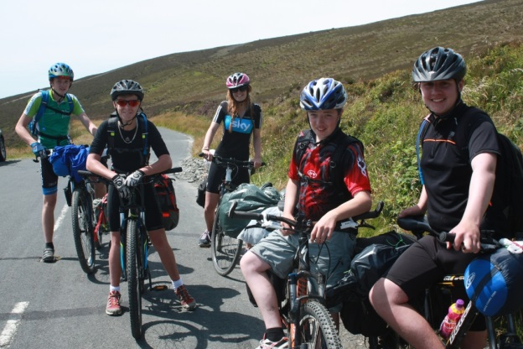

**Property**

We would be grateful if you could ensure that all of your child’s property is clearly labelled with their full name. That way, if anything does get lost and is found and handed in, we can return it to them.

**Many thanks.**

**House Points Update**

We are thrilled to report that our house challenges are off to an exhilarating start!

Each week, students have been engaging in intense tutor quizzes, pushing their knowledge to new heights, and earning valuable CARE achievement points in their lessons, all contributing to our thrilling house competition.

As it stands, the points are as follows:

**Threshlyn** leading with an impressive **990** house points,

closely followed by **Caaig** with **919**,

**Shirragh** with a commendable **784**

and **Foillan** with **743**

Looking ahead, our next challenge, led by our Librarian, invites students to showcase their artistic flair by designing their own bookmarks. With house points up for grabs, it is a chance for every student to shine and contribute to their house success.

**The Importance of Reading**

With the nights drawing in and the weather getting colder, this would be an ideal time to encourage your child to read – whether it be fact or fiction. Reading has so many benefits and isn’t just applicable to English lessons. Children who are weak readers will struggle just as much in Maths, Sciences and even Art! Even 20 minutes a day can make a difference.

The brain is a muscle, and like any muscle, needs exercising. Reading IS that exercise – it improves memory function – you need to remember the plot, the characters and other details each time you pick up the book.

Did you enjoy watching that film? Chances are it will have been based on a book, which, unlike a film, requires total immersion and concentration rather than sitting staring at a screen. Reading cannot happen without focus and in order to fully understand the story, we have to concentrate on each page that we read. In a world where gadgets are only getting faster and shortening our attention span, we need to constantly practice concentration and focus. Reading is one of the few activities that requires your undivided attention, therefore, improving your ability to concentrate.

Books have the power to improve your vocabulary by introducing new words. The more you read, the more your vocabulary will grow, thus improving your ability to communicate effectively with others. You will also improve your writing skills, particularly if you read different authors or genres. Without realising it, even when you read fiction books, you can often pick up random facts that you might not otherwise have known.

Importantly, reading can help to improve sleep - by setting your phone aside and picking up a book, you are telling your brain that it is time to quieten down and relax, thus improving your quality of sleep. Reading also aids in reducing stress – by taking you away from the daily monotonous grind and transporting you to other places, it can lower your heart rate and reduce blood pressure.

Books allow us to experience realities outside of our lives, irrespective of genre. Reading helps you develop empathy as you experience the struggles (or otherwise) of the characters in the book; they can be motivational and help you stay positive about situations irrespective of whether it is a romance novel or a self-help book.

All our students are welcome to borrow books from the school library, which is open before school and at break and lunchtimes. A good website to browse through is <https://schoolreadinglist.co.uk/> which gives recommended reading lists for all school years, many of which can be found in the school library.

**Enrichment Clubs**

We have a fabulous selection of enrichment clubs available, both during and after school, meaning that there should be something to suit everyone! The full list (including sports clubs) can be viewed on our school website –

<https://qe2.sch.im/pages/index/view/id/23/Co-Curricular>

Please note that the PE Department has its own Facebook page, celebrating sporting successes and giving details of fixtures and other useful information. Be sure to follow them -

<https://www.facebook.com/Queen-Elizabeth-II-High-School-Sport-139995876459199/?fref=pb&hc_location=profile_browser>

If your child is celebrating any achievements, either sporting or otherwise, please send details through to [qe2enquiries@sch.im](mailto:qe2enquiries@sch.im) and we will be happy to share their success with the wider community.

On Thursday 12th September we held our annual Prize Giving Ceremony, celebrating the successes of students across all year groups.

Our Guest of Honour for the evening was Hon Daphne Caine, MHK and Minister for Education, Sport and Culture.

Below are just a small selection of photographs from the evening. More photographs will shortly be available on our school website – <https://qe2.sch.im/>

**Annual Prize Giving**

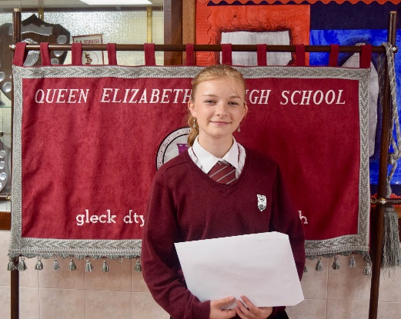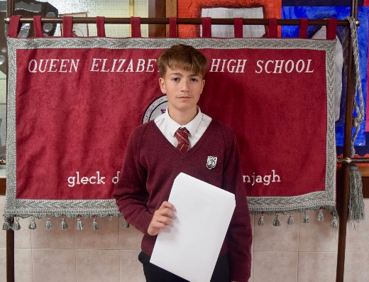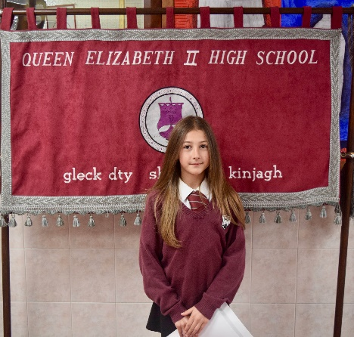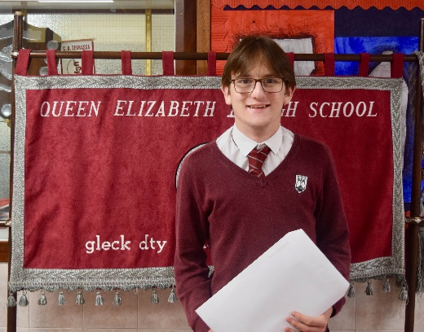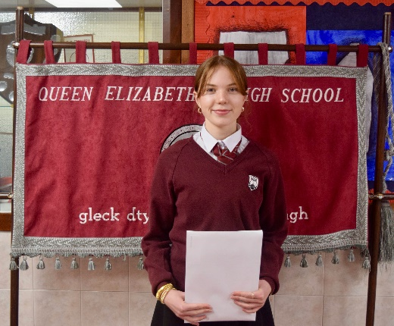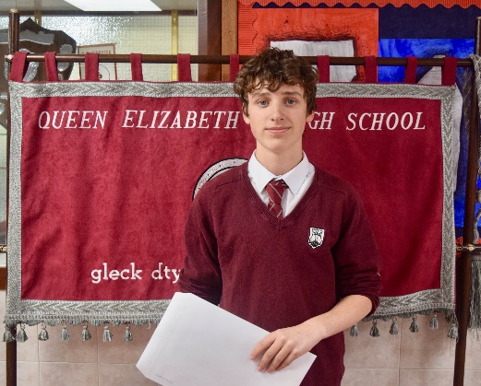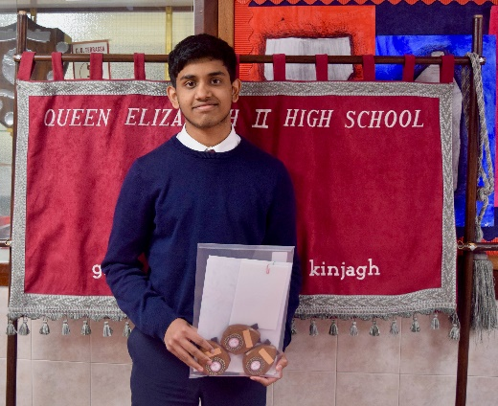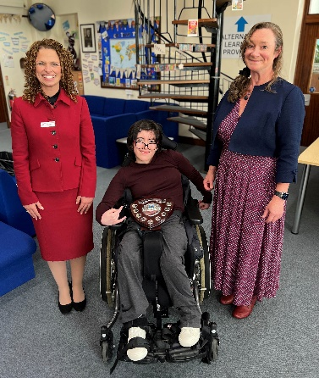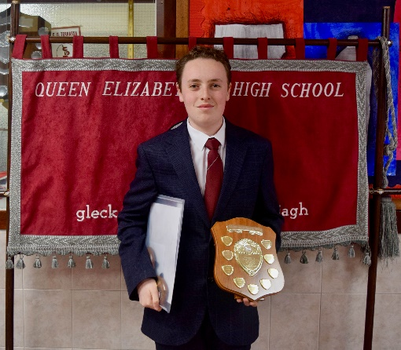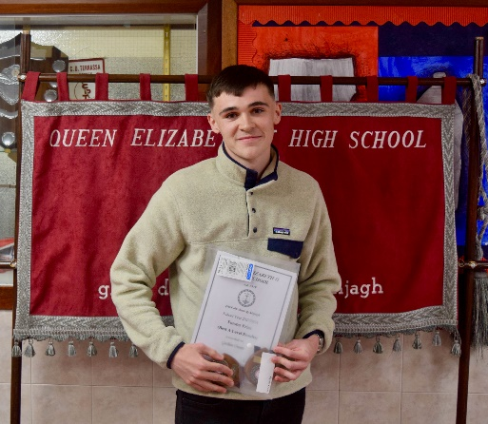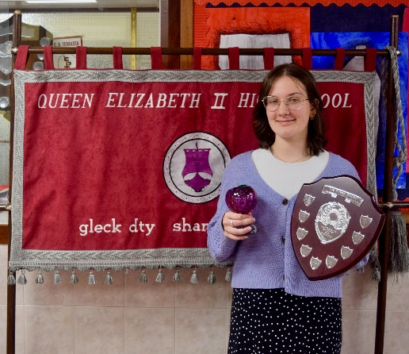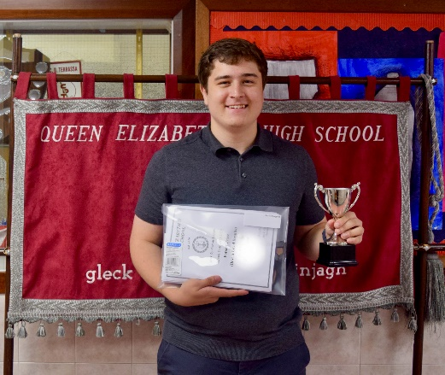

**QEII High School Association**

**News and Events**

A very big **THANK YOU** to all our loyal supporters!

QEII High School Association is a registered charity and is run by enthusiastic volunteers who arrange fundraising events throughout the year. Our next meeting will take place on **Wednesday 11th December at 5.00pm** in the school Library.



**Dates for your diary……**

**Wednesday 4th December -** our **Christmas Fayre** will be heldin the Main Hall between 6.00pm and 8.30pm.

Stalls are £15.00 each. If you would like to reserve a stall, please call Sue Ferns in the School Office on 841000.

On the night there will be a great selection of stalls from local crafters and traders, a Santa’s Grotto, student stalls and

games, refreshments and some fabulous raffle prizes up for grabs!

Admission is £1.00 for adults, which includes entry into a Lucky Programme Draw, 50 pence for children and free for

under 5’s.

**Raffle Prizes**

We will generally hold a Raffle at each of our fundraising events and are always grateful to receive donations of prizes. If you have any suitable items that you would be willing to donate, please drop them off at the School Reception.

**Many thanks**

**(Isle of Man Registered Charity Number 799)**



**Easyfundraising**

Easyfundraising is a shopping directory listing some of your favourite online stores. By selecting Queen Elizabeth II High School as your chosen cause, whenever you shop online, and at no extra cost to you, the charity will receive a donation of up to 15% from every purchase you make.

Please sign up via <https://www.easyfundraising.org.uk/causes/qe2hs/> or scan the following QR code to take you directly

to our link-

QEII High School Association has its own Facebook page. For useful information please be sure to follow us – <https://www.facebook.com/QEIIPeel>

**October**

**Monday 28th October – Friday 1st November –** Half Term

**January**

**Tuesday 7th January –**

Years 12 and 13 Parents’ Evening

**Wednesday 15th January –**

Year 7 Parents’ Evening

**Tuesday 28th January –**

Year 8 Parents’ Evening

**May**

**Monday 5th May –** Bank Holiday

**Tuesday 20th May –** Heats Day

**Monday 26th May –** Bank Holiday

**Tuesday 27th – Thursday 29th May –** Key Stage 3 Exams

**Friday 30th May –** Inset Day (School closed to students)

**Important dates…….**

**December**

**Monday 2nd – Friday 6th December –** Year 13 Mock Exams

**Wednesday 4th December –**

QEII High School Association Christmas Fayre, 6.00pm until 8.30pm in the Main Hall

**Wednesday 11th December –**

Year 11 Parents’ Evening

**Wednesday 11th December –**

QEII High School Association Meeting, 5.00pm in the Library

**Monday 16th December –**

Christmas Concert

**Monday 23rd December – Friday 3rd January 2025 –** Christmas Holidays

**November**

**Wednesday 13th November –**Open Evening for Year 6 children and parents

**Monday 18th – Friday 29th November –** Year 11 Mock Exams

**June**

**Monday 2nd – Friday 6th June –** Half Term

**Tuesday 10th June –**

ReserveHeats Day

**Thursday 19th June –**

New Intake Day

**Friday 20th June –**

Sports Day

**Monday 23rd – Friday 27th June –** Year 12 Mock Exams

**February**

**Friday 7th February –**

Wind Band Concert

**Thursday 13th February –**

Dance Showcase

**Monday 17th – Friday 21st February –** Half Term

**April**

**Wednesday 2nd April –**

Year 10 Parents’ Evening

**Monday 7th – Monday 21st April (inclusive) –** Easter Holidays

**March**

**Wednesday 5th March –**

14 - 19 Information Evening for Years 9 and 11

**Monday 10th – Friday 14th March –** Year 10 Mock Exams

**Monday 31st March –**

Spring Showcase

**July**

**Monday 7th July –**

Tynwald Day

**Friday 18th July –**

School closes for Summer Term

**Summer 2014 Results Days**

**GCE – Thursday, 14th August**

**GCSE – Thursday 21st August**

Results are available from **9.30am** onwards in the Sixth Form Block.

You can only collect your own results. If you are unable to collect your results in person, you may authorise someone else to collect them on your behalf. This authorisation **MUST** be in writing. Alternatively, if you provide a stamped addressed envelope before you leave School, we will post your results to you.

Results **WILL NOT** be supplied by telephone, fax or email under **ANY** circumstances.

**No results will be given out to anyone else without a letter of permission.**