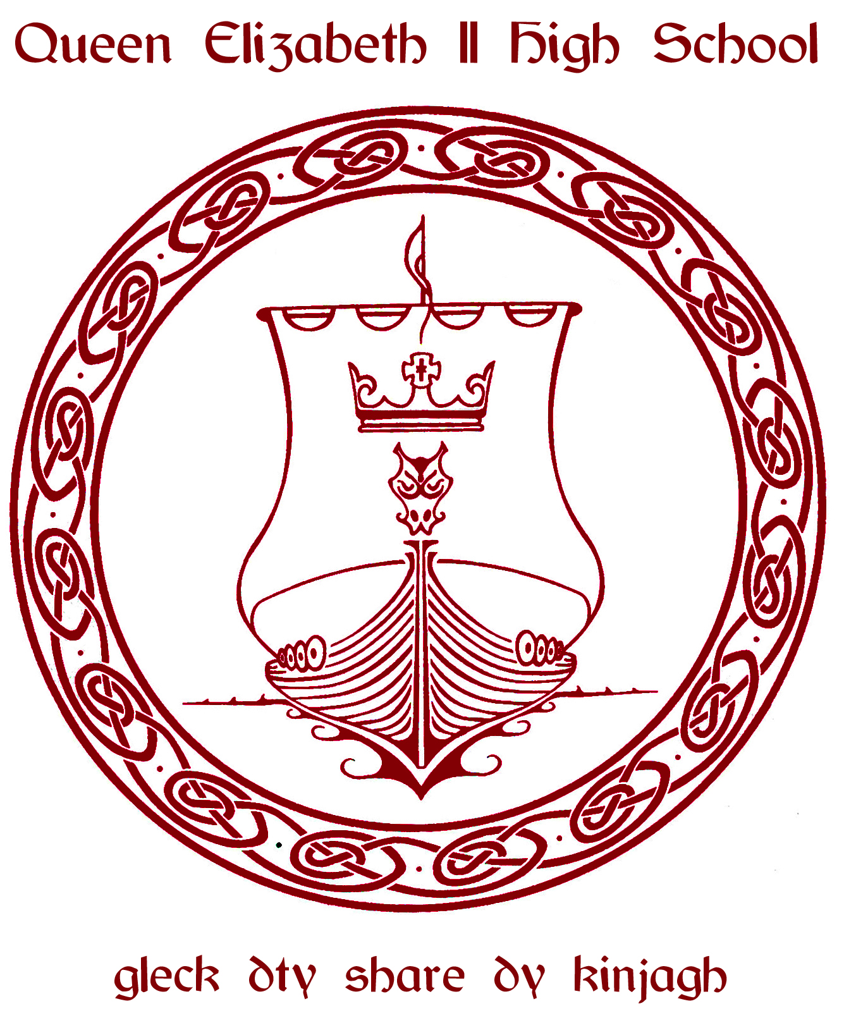
NAME: ______________________________________ TUTOR GROUP: ____________

In Years 10 and 11 English, Maths and Science are compulsory. There is some choice for your other 4 subjects. The purpose of this form is to tell us which KS4 courses you would ideally like to study in Years 10 and 11.

What you have to do:
- Please place a number 1 to 4 against the 4 courses you would like to do in Years 10/11. Please number them in order of preference i.e.
  - 1 = the subject you most want to do etc.
  - 4 = your fourth preference
- Please now put a 5 and 6 against two more subjects
  - These will form your ‘reserve’ choices. That means if we can’t make the options grid up so that can do all of your 1 to 4 choices, hopefully we’ll be able to set things so you can do one or more of your reserves
Subject | 1 to 6
Art
ASDAN COPE
Business Studies
Design Technology (Food & Nutrition or Textiles or Product Design or SQA Practical Woodwork) ¹
Please CIRCLE which Design Technology subject you are interested in (ONE ONLY)
Computer Science or ICT (SQA)
Please circle which of the two options you are interested in (ONE ONLY)
Dance
Drama
Child Development and Care or Hairdressing & Beauty Therapy or Hospitality and Catering ²
Please circle which option you are interested in (ONE ONLY)
French
Geography
German
Graphics
History
Manx
Music
Physical Education
Progression Pathway – Technology or Community ³
Please circle which option you are interested in (ONE ONLY)
Religious Studies
NOTES
1 You can only pick one Design Technology subject from this box as they have to run at the same time.
2 These subjects will be taught at UCM. Students will be taken there on a specially charted bus for a morning or afternoon session. You can only take one subject from this box as they all run at the same time.
3 ‘Progression Pathway’ courses are also taught at UCM (see note 2) and each pathway provides different taster sessions of the post 16 courses offered at UCM. You will obtain a variety of useful qualifications/ certificates (e.g. on the ‘Technology’ pathway, you can achieve a City & Guilds Level 1 in Construction Skills) as part of the course but it doesn’t lead to a IGCSE/ BTEC qualification. This course is usually recommended to specific students by Learning Support.

PLEASE NOTE:
We will try and make the options block we create from this information fit as many people’s preferences as possible. WE CANNOT GUARANTEE THAT WE CAN GIVE EVERYONE THEIR FIRST FOUR CHOICES.
PLEASE RETURN THIS FORM BY WEDNESDAY 11TH MARCH 2020.

Signature Student
Signature Parent/Guardian

